

|  |
| --- |
| **Consortium Members** |
|  |



ESA Sea Level CCI

Validation Report: WP2100 Altimeter Instrumental Processing

|  |  |
| --- | --- |
| Reference: | CLS-DOS-NT-12-51 |
| Nomenclature: | SLCCI-VR-19 |
| Issue: | 1. 1 |
| Date: | Mar. 12, 12 |

| Chronology Issues: | | | |
| --- | --- | --- | --- |
| Issue: | Date: | Reason for change: | Author |
| 1.0 | Sept 12, 11 | Initialization | P.Thibaut |
| 1.1 | Jan 30, 12 | Update of the initial version | P.Thibaut |
|  |  |  |  |
|  |  |  |  |
|  |  |  |  |
|  |  |  |  |

|  |  |  |
| --- | --- | --- |
| People involved in this issue: | | |
| Written by (*): | P.Thibaut (CLS) | Date + Initials:( visa or ref) |
| Checked by (*): | G Timms (Logica) | Date + Initial:( visa ou ref) |
| Approved by (*): | G Larnicol (CLS) | Date + Initial:( visa ou ref) |
| Application authorized by (*): | ESA | Date + Initial:( visa ou ref) |

*\*In the opposite box: Last and First name of the person + company if different from CLS*

|  |  |
| --- | --- |
| Index Sheet: | |
| Context: | Baghera tool, project ACT-OCEAN |
| Keywords: | Oceanography, sea level |
| Hyperlink: |  |

| Distribution: | | |
| --- | --- | --- |
| Company | Means of distribution | Names |
| CLS | Notification |  |

|  |
| --- |
| List of tables and figures |

List of tables:

**Aucune entrée de table d'illustration n'a été trouvée.**

List of figures:

Figure 1 [Diagnosis A201-a]: Temporal evolution of the Sea Level anomaly (SLA) with the new PTR correction only (red) and reference (blue) 3

Figure 2 [Diagnosis A201-a]: Temporal evolution of the Sea Level anomaly (SLA) with all new instrumental corrections (red) and reference (blue) 4

Figure 3 [Diagnosis A201-a]: Temporal evolution of SSH differences between tide gauges and altimetry measurements with the new PTR correction only (red) and reference (blue) 5

Figure 4 : Temporal evolution of SLA anomaly for Envisat/RA-2 (including CCI corrections) (red) and Jason-1 mission (blue) (upper panel). Same plot with the RA-2 reference data on lower panel 6

Figure 5 [Diagnosis A001]: Temporal evolution of differences between PTR instrumental correction over Envisat period 7

Figure 6: [Diagnosis A204-a] Maps of MSL trend differences between CCI instrumental correction and RA-2 reference products. 8

Figure 7: difference between CCI and IPF variance of the corrections for the PTR_Time_Delay 9

Figure 8: [Diagnosis A102] Temporal evolution of SSH variance differences using successively new instrumental and reference corrections in the SSH calculation for RA-2 10

Figure 9: [Diagnosis A001] Evolution of the standard deviation differences between new and reference corrections in the SSH calculation for RA-2 11

|  |
| --- |
| List of items to be confirmed or to be defined |

Lists of TBC:

Aucune entrée de table des matières n'a été trouvée.

Lists of TBD:

Aucune entrée de table des matières n'a été trouvée.

|  |
| --- |
| Applicable documents |

AD Sea level CCI project Management Plan  
CLS-DOS-NT-10-013

|  |
| --- |
|  |

|  |
| --- |
| Reference documents |

RD 1 Manuel du processus Documentation  
CLS-DOC

RD 2 Envisat RA-2 PTR drift, P.Thibaut & A.Ollivier. March 2010  
CLS-DOS-NT-10-071 2.0

|  |
| --- |
|  |

|  |
| --- |
| List of Contents |

1. Introduction 1

2. Global Mean Sea Level 2

2.1. Long-term evolution 2

2.1.1. Validation diagnoses used 2

2.1.2. Instrumental Corrections dedicated to Envisat/RA-2 2

2.1.2.1. Impact of the reversion of the PTR correction 2

2.1.2.2. Impact of the reversion of the PTR correction on ascending and descending tracks 3

2.1.2.3. Impact of the complete instrumental corrections 4

2.1.2.4. Comparison of the RA-2 MSL with complete instrumental corrections with tide gauges 5

2.1.2.5. Comparison of the RA-2 MLS (including complete instrumental corrections) with Jason MSL 5

2.2. Inter-Annual signals 7

2.2.1. Validation diagnoses used 7

2.2.2. Instrumental Corrections dedicated to Envisat/RA-2 7

3. Regional Mean Sea Level 7

3.1. Long-term evolution 7

3.1.1. Validation diagnoses used 7

3.1.2. Instrumental Corrections dedicated to Envisat/RA-2 8

3.2. Annual and semi-annuals signals 8

3.2.1. Validation diagnoses used 8

3.2.2. Instrumental Corrections dedicated to Envisat/RA-2 8

3.3. Coastal areas 9

3.4. High latitudes 9

4. Mesoscale 9

4.1. Validation diagnoses used 9

4.1.1. Instrumental Corrections dedicated to Envisat/RA-2 10

5. Conclusions and recommendations 11

Appendix A - Synthesis 12

5.1. Envisat 13

Appendix B - Definition of the indicator value 14

Appendix C - List of acronyms 15

# Introduction

The main objective of this document is to provide the analysis of the RRDP reports dedicated to the altimeter instrumental correction of the sea level (WP2100) in order to evaluate new instrumental corrections to improve the sea-level computation for climate applications.

The major aim of WP2100 is to provide a set of new instrumental corrections. The peculiarity of the instrumental correction is that we know that some instrumental behaviours have to be accounted for and that we know how to take them into account. Most of the time, we have no doubt on how to apply corrections. However, in this work package, we have proposed different corrections, with associated RRDP (Round Robin Data Package), in order to quantify the impact of each singular correction.

It was initially in our plans to benefit of the reprocessed ERS data (output of the Reaper project). However, because of the delay of the Reaper project, it has not been possible to wait for them and to analyse its output. WP2100 is thus fully dedicated to the Envisat/RA-2 instrumental corrections.

Four main corrections have been implemented and tested:

* **Improvement of the resolution the PTR (Point Target Response) instrumental correction** (Power of the PTR and Time_Delay). This improvement has been already taken into account by isardSAT in the RA-2 L1b IPF. RA-2 reprocessed products (IPF V2.1, 2011) account for this evolution. The improvement of resolution is obtained via 0-padding of PTR measurements.
* **Inversion of the sign of the PTR Time_Delay Correction in Ku band.** The SLCCI project is the first project that has analysed the impacts of this correction even if this evolution was proposed more than 2 years ago. The current RA-2 reprocessing activity doesn’t include this evolution because it was not mature enough and agreed by ESA at the beginning of the reprocessing. The theoretical justification of this modification has been described in a technical note (Thibaut, RD1). This is the result of the work done by CLS, made possible thanks to related studies in the frame of CNES SALP project on Jason altimeters. This evolution has been discussed and accepted during a dedicated meeting in Barcelona with ESA (ESRIN and ESTEC), TAS Italy, isardSAT and CLS people (February 2011).
* **Introduction of the IF filter effects in the PTR processing**. PTR measurements account for the receiving chain of the altimeter. It is therefore necessary to correct the PTR measurements by the IF filter.
* **Improvement of the USO correction**. This improvement has been already taken into account by isardSAT in the RA-2 IPF. Reprocessed products (IPF V2.1, 2011) account for this evolution.

The following RRDP have been performed for the Envisat mission:

* Comparison of the new PTR time delay correction with respect to the reference products (see hereafter) 🡺 to show the impact of the sign inversion and resolution of the PTR
* Comparison of the new PTR time delay correction (with the IF mask correction included) with respect to the new PTR time delay correction 🡺 to show the impact of the filter correction
* Comparison of the new USO correction applied to the tracker range with respect to the reference products (see hereafter) 🡺 to show the impact of the new USO correction
* Comparison of the sum of all the evolutions (PTR sign + PTR resolution + IF filter + USO correction) with respect to the reference products (see hereafter) 🡺 to show the global impact of the proposed evolutions

The reference corrections are the corrections that have been implemented in the RA-2 ground segment and that will be called “IPF” in the following paragraphs and on the legends of the figures. The IPF version is the one used in the ground processing since the launch. **We do not account for RA-2 reprocessed data** (in 2011) that were not available at the date of the study.

To achieve this WP, all the RA-2 L0 data from cycles 10 to 90 have been reprocessed (L1b). All the reference L0 and L1b data have been unpacked from the CNES LTA data center (4To of data) in order to be able to substitute the current corrections by the new ones.

These RRDP have been performed on points where the studied corrections are valid. Transition between RA-2 chain A and chain B has been accounted for. For calibration data (PTR), measurements are done on-board either in Ku band or in S band. There are sequentially 3 measurements in Ku band and then 1 in S Band. We have not interpolated the data. Consequently, the considered points don’t represent the whole data set (only 3 out of 4 points in Ku band, 1 out of 4 in S band).

For the Point Target Response, Ku and S band corrections are provided. However, the S band range is only computed to correct the Ku range for the ionospheric effects. We have not computed any S band SSH field (because some corrections like the SSB or the ionospheric corrections have never been defined in S band).

Analyses have also been done on parameters deduced from the PTR measurements even if they have not direct contributions to the range. The width of the PTR is thus monitored. Any evolution of this parameter impacts the Significant Wave Height (SWH) estimates and thus the Sea Sate Bias correction and consequently the Ku SSH. Similarly, the evolution of the power of the PTR has been monitored. Any evolution of this parameter impacts the backscaterring coefficient, thus the windspeed and the Sea Sate Bias correction and consequently the Ku SSH.

This document presents the impact of all new algorithms separating the different climate applications defined in the sea level CCI URD (User Requirement Document) and separating several temporal scales related with climate applications. A clear and easy understandable impact indicator has been defined and is described in the appendix of this document (see Appendix B).

# Global Mean Sea Level

## Long-term evolution

### Validation diagnoses used

The validation diagnosis of the long-term sea-level evolution (A201-a) allows us to evaluate the impact on the global MSL trend using successively the different corrections. Their impact is also analyzed separating descending and ascending passes (A201-b) and north-south hemisphere analyses: the reduction of the MSL trend differences is a good quality criterion to determine which correction is the best. Cross-comparison of MSL trends between altimeter missions collocated on the same period (B001) and the comparison with in-situ measurements (tide gauge C001) also give a relevant indication to know whether the potential drift of altimeter MSL is reduced or not with new corrections.

### Instrumental Corrections dedicated to Envisat/RA-2

#### Impact of the reversion of the PTR correction

For Envisat, the main evolution of the SLA is observed with the new PTR correction sign reversion. The impact of the reversion of the sign of the PTR correction can be seen on the global MSL trend (Δ=+2 mm/yr) when comparing the new PTR correction with PTR correction used in the historical RA-2 products.

Even if we know (from Jason experience) that it is important to correct the PTR for IF filter effects, the results obtained by the dedicated RRDP doesn’t show clear trends. It clearly indicates that the evolution of the RA-2 IF filter is small.

The following table gives the evolution of SLA trends for the PTR correction RRDP.

|  |  |  |  |
| --- | --- | --- | --- |
| Altimetric missions | IPF  (Reference) | CCI_PTR_Correction | CCI PTR Correction With_IF mask |
| Envisat | 0.66 mm/yr | 2,66 mm/yr | 2.65 mm/yr |

Table 1: [Diagnosis A201-a] Impact of new PTR corrections on global MSL trends for Envisat/RA-2

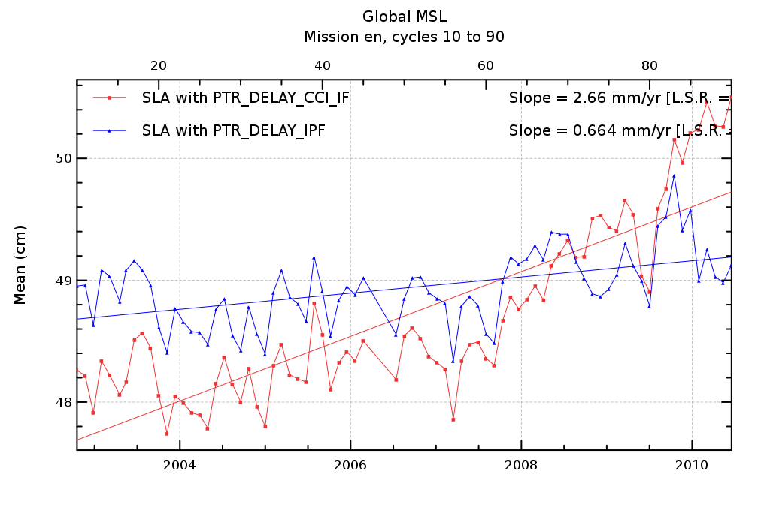

Figure [Diagnosis A201-a]: Temporal evolution of the Sea Level anomaly (SLA) with the new PTR correction only (red) and reference (blue)

#### Impact of the reversion of the PTR correction on ascending and descending tracks

Concerning the consistency of the global MSL trend as seen by ascending or descending tracks (A201), we don’t expect to detect any impact of the instrumental correction on this diagnosis. This is shown in the following table where the global MSL trend difference between ascending and descending tracks is quite the same for the PTR correction (around 2 mm/yr). Therefore, in this case, this diagnosis is not relevant to determine the best correction for the long-term evolution of the global MSL.

|  |  |  |  |
| --- | --- | --- | --- |
| Altimetric missions | IPF (Reference) | CCI_PTR_Correction | Delta PTR correction |
| Envisat ascending | 0.222 mm/yr | 2.15 mm/yr | = 1.92 mm/yr |
| Envisat Descending | 1.19 mm/yr | 3.25 mm/yr | = 2.06 mm/yr |

Table : [Diagnosis A201-b] Global MSL trend differences between ascending and descending passes for Envisat

#### Impact of the complete instrumental corrections

The following table and plot give the evolution of SLA trends when integrating all the instrumental corrections (output of the final RRDP). We must notice that these values have been obtained for the period “cycle 10 to cycle 84” only.

|  |  |  |
| --- | --- | --- |
| Altimetric missions | IPF  (Reference) | CCI_Instrumental_Correction |
| Envisat | 0.675 mm/yr | 2,14 mm/yr |

Table : [Diagnosis A201-a] Impact of all new instrumental corrections on global MSL trends for Envisat/RA-2



Figure [Diagnosis A201-a]: Temporal evolution of the Sea Level anomaly (SLA) with all new instrumental corrections (red) and reference (blue)

#### Comparison of the RA-2 MSL with complete instrumental corrections with tide gauges

Tide gauges are used as an external independent reference (C001) to assess the drift of the global MSL. The following table indicates the MSL drift difference between Envisat data and in-situ data with various instrumental corrections. The accuracy of the method of comparison with tide gauges on Envisat time series is close to 0.5 mm/yr. And yet the three observed values (see the following table) are very close to each other (differences much below this error value).

|  |  |  |  |
| --- | --- | --- | --- |
| Altimetric missions | IPF  (Reference) | CCI_PTR_Correction | CCI PTR Correction With_IF mask |
| Envisat | = -0.542 mm/yr | 0.0475 mm/yr | No impact |

Table 4: [Diagnosis C001] Impact of instrumental corrections on global MSL trends detected with tide gauges for Envisat

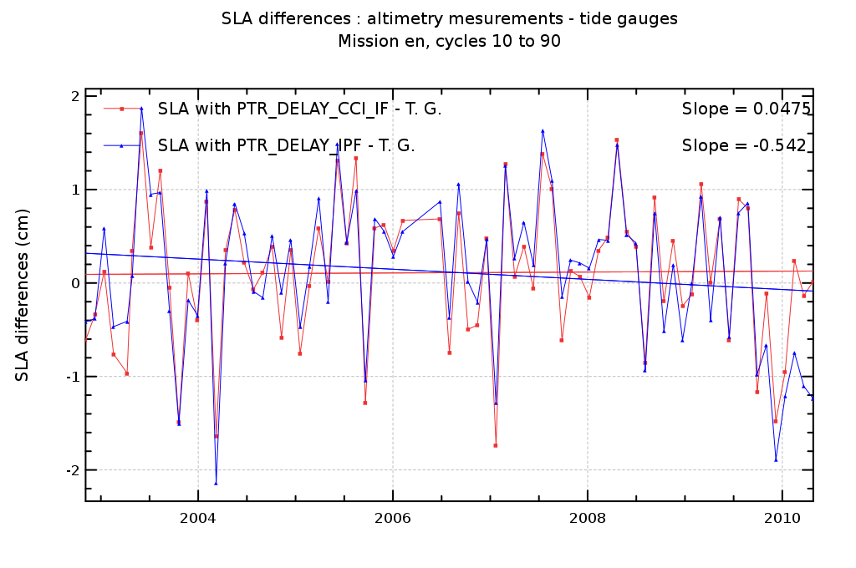

Figure [Diagnosis A201-a]: Temporal evolution of SSH differences between tide gauges and altimetry measurements with the new PTR correction only (red) and reference (blue)

#### Comparison of the RA-2 MLS (including complete instrumental corrections) with Jason MSL

Jason-1 MSL can be used as an external independent reference (Diagnoses B201) to assess the drift of the global MSL. The following table indicates the MSL drift difference between Envisat/RA-2 data and Jason-1 data including the CCI instrumental corrections on RA-2 .

**A much better agreement can be seen now between both missions.** The difference between the MSL was 1.73 mm/yr before the CCI study and is now around 0.3 mm/yr.

|  |  |  |
| --- | --- | --- |
| Altimetric missions | IPF  (Reference) | CCI_instrumental_Correction |
| Envisat |  mm/yr | 2.28 mm/yr |
| Jason | 2.57 mm/yr | / |

Table : [Diagnosis B201] Comparison of Envisat/RA-2 (including CCI corrections) and Jason-1 global MSL trends

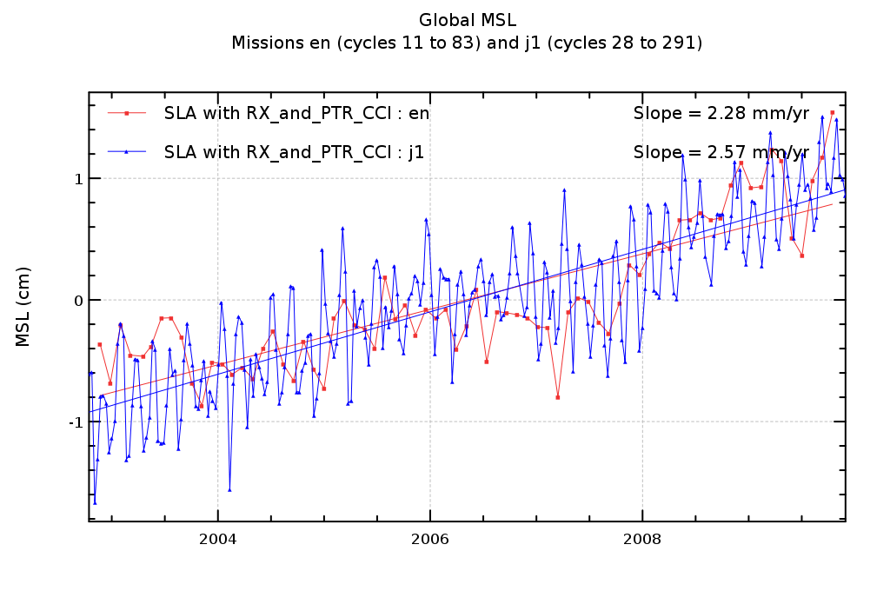

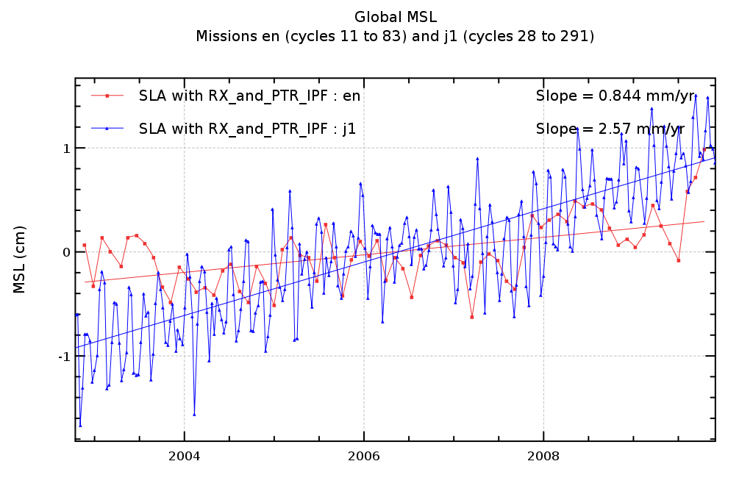

Figure : Temporal evolution of SLA anomaly for Envisat/RA-2 (including CCI corrections) (red) and Jason-1 mission (blue) (upper panel). Same plot with the RA-2 reference data on lower panel

## Inter-Annual signals

### Validation diagnoses used

The monitoring of the differences between corrections (Diagnostic A001) provides information concerning the impact of the studied correction on the global MSL at inter-annual time scales.

### Instrumental Corrections dedicated to Envisat/RA-2

The monitoring of the instrumental PTR correction difference (Diagnostic A001) reveals two significant jumps (10 mm at the end of 2008 and 14 mm at the end of 2009). It has been theoretically demonstrated that the inversion of the sign of the correction was mandatory. The improvement of the resolution of the PTR correction is also mandatory to observe small evolutions of the instrument due to ageing (at inter annual scale). To our point of view, it is clear that not taking these evolutions in consideration would induce a bad interpretation of inter-annual signals especially at the end of the serie. It is thus crucial to take these instrumental evolutions into account.

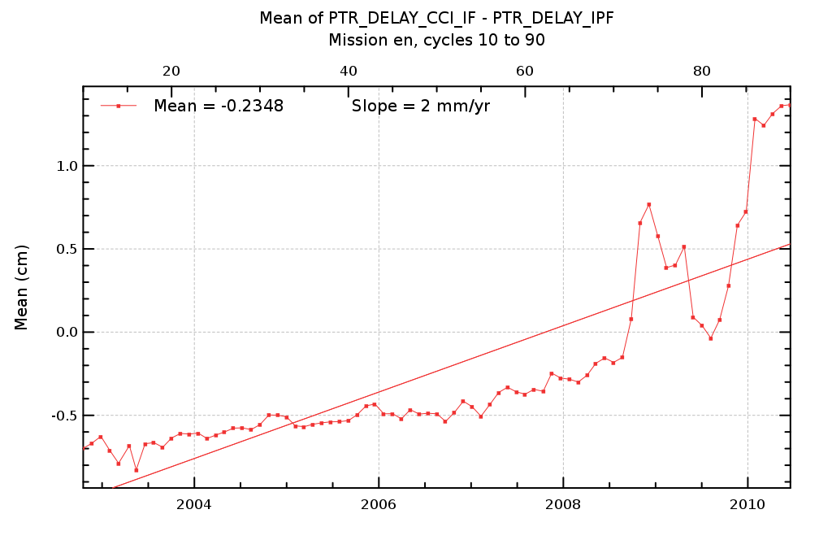

Figure 5 [Diagnosis A001]: Temporal evolution of differences between PTR instrumental correction over Envisat period

# Regional Mean Sea Level

## Long-term evolution

### Validation diagnoses used

The validation diagnosis of the regional trend of sea-level differences using successively two different corrections (CCI instrumental corrections and reference) (A204a) allows us to evaluate the impact of these corrections on the local MSL trends. Their impact may also be analyzed separating descending and ascending passes (A204b) but this diagnosis is not the most relevant concerning the instrumental corrections. Cross-comparison of MSL trends evolution between altimetry missions collocated on the same period (B202) may also give a relevant indication of whether the potential MSL drift is reduced or not with the studied correction.

### Instrumental Corrections dedicated to Envisat/RA-2

The following map shows the difference of the new RA-2 MSL with respect to the reference products (integrated over 80 cycles). A clear hemispherical signal (amplitude around 0.2 mm/yr between north and south hemispheres) appears even if there is no reason to consider (to this point of view) that the new corrections are better than the previous ones.

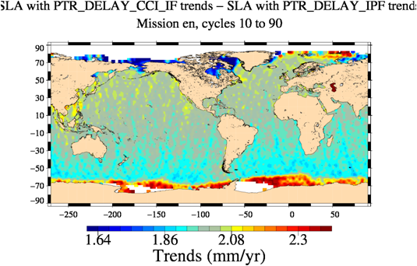

Figure 6: [Diagnosis A204-a] Maps of MSL trend differences between CCI instrumental correction and RA-2 reference products.

## Annual and semi-annuals signals

### Validation diagnoses used

The analyses of periodic signals of regional mean sea level are performed thanks to diagnosis A205 where the difference of amplitudes and phases between SLA using successively new instrumental corrections and reference corrections are mapped for annual and semi-annual signals. These diagnoses allow us to characterize the local or regional impact of new corrections.

### Instrumental Corrections dedicated to Envisat/RA-2

We have not observed any particular signals in the maps obtained (either in phase or amplitude).

## Coastal areas

Concerning the instrumental corrections, there is no reason to observe any dependency with the overflown surface. Indeed, the calibration measurement on-board process that measures the Point Target Response (PTR) is a complete internal measurement that doesn’t account of all for the backscattered signals that depend on the surface. Concerning the IF filter, it is measured regularly but integrated and used once a month.

Consequently, we are not expecting any particular improvement on coastal areas. However, we observe a small reduction of the variance of the correction when going off the coasts. We do not have any explanation for that result.

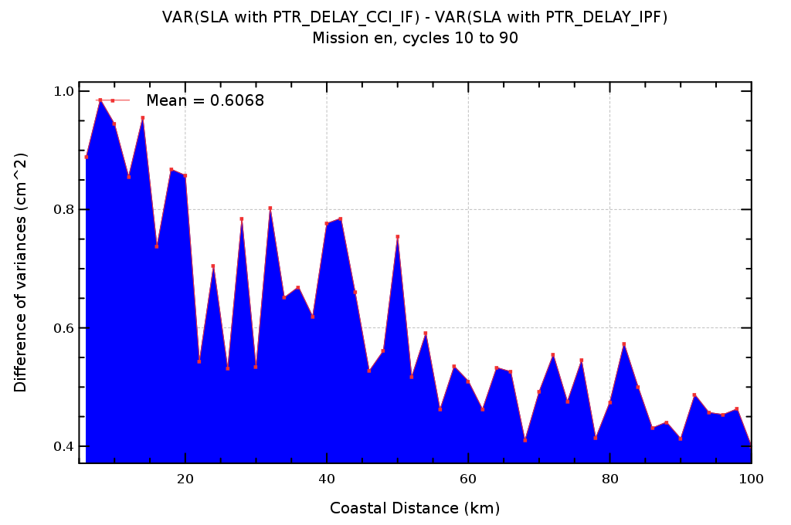

Figure 7: difference between CCI and IPF variance of the corrections for the PTR_Time_Delay

## High latitudes

As for the previous paragraph, there no reason to see any particular impact of this new correction at high latitudes compared with lower bands of latitudes.

# Mesoscale

## Validation diagnoses used

Sea-level analyses at crossover points with along-track data allow us to detect improvements at short temporal scales (< 2months) for mesoscale application. The most relevant diagnoses performed in RRDP are the monitoring and the map of the variance SSH differences using successively 2 different corrections in the sea-level calculation.

Diagnoses A102 displays the long-term monitoring of SSH variance differences relative to a mean sea surface (MSS): the reduction of variance indicates a better consistency with the MSS. Most of the time, it demonstrates an improvement of sea-level computation. But in some few cases, the variance increase can also indicate a systematic error in the MSS due to geographical bias for instance not taken into account.

### Instrumental Corrections dedicated to Envisat/RA-2

We observe an improvement of the SSH variance when using the new CCI corrections mainly because the resolution of the PTR correction has been increased. At the end of the period, a jitter between 2 values of the PTR correction was observed on the reference products. This is no more the case with the new corrections inducing a better correction between increasing and descreasing passes.

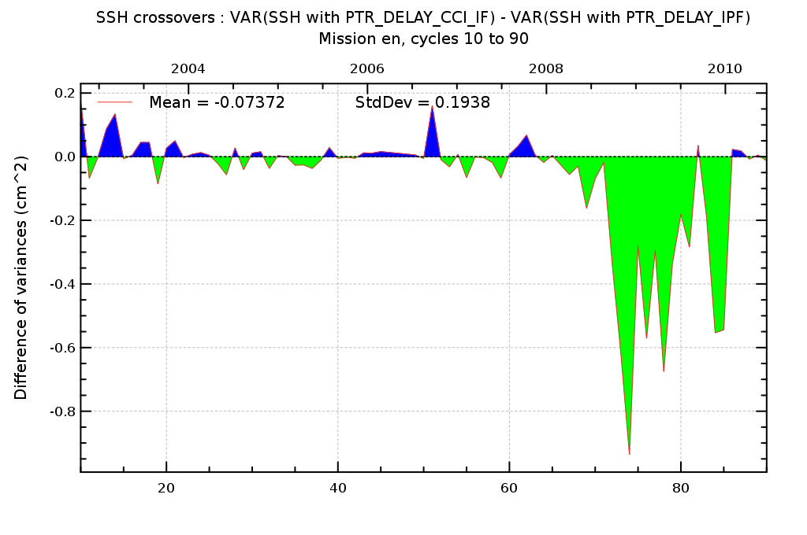

Figure : [Diagnosis A102] Temporal evolution of SSH variance differences using successively new instrumental and reference corrections in the SSH calculation for RA-2

The temporal evolution of the standard deviation of differences between new and reference standards corrections is plotted hereafter. As for the evolution at crossovers and for the same reasons, we observe an increase of this quantity at the end of the period. Both diagrams are coherent.

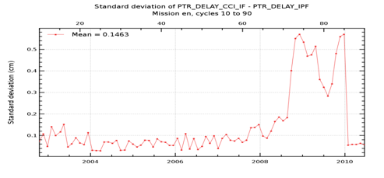

Figure : [Diagnosis A001] Evolution of the standard deviation differences between new and reference corrections in the SSH calculation for RA-2

# Conclusions and recommendations

The aim of WP2100 was to provide a set of new instrumental corrections. The peculiarity of the instrumental correction is that we know that some instrumental features have to be accounted for and that we know (by theory) how to take them into account. Most of the time, we have no doubt on how to apply corrections. The main interest of this work is thus to quantify their impact on the various space and time scales and in particular their impact on the Global Mean Sea Level rise. Because ERS data were not made available at the time of the study, WP2100 has been fully dedicated to the Envisat/RA-2 instrumental corrections.

Four main corrections have been implemented and tested:

1. **Improvement of the PTR (Point Target Response) instrumental correction resolution (Power of the PTR and Time_Delay).** This improvement has been already taken into account by isardSAT in the RA-2 L1b IPF. RA-2 reprocessed products (IPF V2.1, 2011 RA-2 reprocessing activity)

* We recommend to keep this evolution which is also mandatory to observe small evolutions of the instrument due to ageing (at inter annual scale). To our point of view, it is clear that not taking these evolutions in consideration would induce a bad interpretation of inter-annual signals especially at the end of time series. A better resolution of the correction induces an improvement of the SSH variance at crossovers.

1. **Inversion of the sign of the PTR Time_Delay Correction in Ku band.** The SLCCI project is the first project that has analysed the impacts of this correction even if this evolution was proposed more than 2 years ago. The current RA-2 reprocessing activity doesn’t include this evolution because it was not mature enough and agreed by ESA at the beginning of the reprocessing.Based on strong hypotheses on the instrumental processing applied on-board on the waveforms and on the PTR data (sometimes very difficult to confirm 10 years after the launch), this evolution induces an important modification of the slope of the MSL of about +2mm/year that makes the corrected RA-2 global MSL much more coherent with the Jason one and also much more coherent with the tide gauges.

* From both MSL analyses and theoretical study we suspected an anomaly at the PTR level. This study assessed the proposed correction. We consequently clearly recommend to consider this PTR correction reversion and in the future to account for it in the next RA-2 reprocessing campaign.

1. **Introduction of the IF filter effects in the PTR processing**. PTR measurements account for the receiving chain of the altimeter. It is therefore necessary to correct the PTR measurements by the IF filter.

* There is absolutely no doubt that theoretically, this correction must be done even if the CCI study shows no impact on the MSL and only very small impacts on regional or small scales signals..

1. **Improvement of the USO correction**. This improvement has been already taken into account by isardSAT in the RA-2 IPF. Reprocessed products (IPF V2.1, 2011) account for this evolution. The USO correction that was computed in the RA-2 L1b was not correct. The CCI study has allowed to provide a L1b USO correction coherent with the USO correction computed previously in the RA-2 L2

* The recommendation is to use the USO correction which is the same from RA-2 level-1B IPF and Sea-level CCI project.

**Final recommendation:**

* When accounting for all these corrections, it has been showed that the RA-2 MSL is much more coherent with Jason MSL (difference of about 0.3 mm/yr) and with Tide gauges (difference of about 0.0475 mm/yr). In consequence, we recommend to apply all these corrections for future studies and to implement them (those that are not yet implemented) in the ground processing for future reprocessing campaigns.

1. Synthesis

This section synthesizes the impact of the new algorithm dedicated to the instrumental correction for the Envisat altimetric mission and separating the different climate applications defined in the sea level CCI URD (User Requirement Document). The impact is also estimated for several temporal scales impacting climate studies for each application.

In order to have a clear view of these potential impacts, the information is summarized in a single table for the studied altimetric mission. An impact indicator clearly and easily comprehensible has been defined with 3 levels: significant impact, low impact, no impact detected. Each level is represented by a different color box.

The choice of a value indicator (significant, low or null) is quite subjective. As it depends on the application (Global MSL, regional MSL, mesoscale…), the rule to classify this impact has been defined in annex of this document (see ).

## Envisat



|  |  |  |  |  |  |
| --- | --- | --- | --- | --- | --- |
|  | Legend : | Significant impact | Low impact | No impact detected | Not yet evaluated |
|  |  | + | : Positive impact (low) | | |
|  |  | - | : Negative impact (significant) | | |

1. Definition of the indicator value

In this table, the choice of the indicator value is defined for each climate applications and temporal scales. The thresholds defined here are valid for time series long enough (> 7 years). If time series is too short, the thresholds have to be majored.

|  |  |  |  |  |
| --- | --- | --- | --- | --- |
| Climate  Applications | Temporal Scales | Definition of the indicator value | | |
| Significant impact | Low impact | No impact detected |
| Global Mean Sea Level | Long-term evolution (trend) | Trend >0.15 mm/yr | Trend> 0.05 mm/yr | Trend< 0.05 mm/yr |
| Inter annual signals (> 1 year) | Amplitude> 0.5 mm | Amplitude> 0.2 mm | Amplitude< 0.2 mm |
| Annual and semi-annual Signals | Amplitude> 1 mm | Amplitude> 0.2 mm | Amplitude< 0.2 mm |
| Regional Mean Sea Level | Long-term evolution (trend) | Trend > 0.5 mm/yr | Trend> 0.1 mm/yr | Trend< 0.1 mm/yr |
| Annual and semi-annual Signals | Amplitude> 5 mm | Amplitude> 0.5 mm | Amplitude< 0.5 mm |
| Mesoscale | Signals < 2 months | Crossovers Variance differences > 1 cm² | Crossovers Variance differences > 0.2 cm² | Crossovers Variance differences < 0.2 cm² |
| Specific regional areas of main interest for climate studies: | | | | |
| Coastal areas | Long-term evolution (trend) | Trend > 0.5 mm/yr | Trend> 0.1 mm/yr | Trend< 0.1 mm/yr |
| Signals < 2 months | Crossovers Variance differences > 1 cm² | Crossovers Variance differences > 0.2 cm² | Crossovers Variance differences < 0.2 cm² |
| High latitudes | Long-term evolution (trend) | Trend > 0.5 mm/yr | Trend> 0.1 mm/yr | Trend< 0.1 mm/yr |
| Signals < 2 months | Crossovers Variance differences > 1 cm² | Crossovers Variance differences > 0.2 cm² | Crossovers Variance differences < 0.2 cm² |

1. List of acronyms

|  |  |
| --- | --- |
| TBC | To be confirmed |
| TBD | To be defined |
| AD | Applicable Document |
| RD | Reference Document |