Consortium Members

ESA Sea Level CCI

Product Validation and Algorithm Selection Report
Reference: | CLS-DOS-NT-12-125
Nomenclature: | SLCCI-PVSAR-28
Issue: | 1. 2
Date: | Sep. 3, 12

Chronology Issues:
Issue: | Date: | Reason for change: | Author
1.0 | 10/06/12 | Creation | M.Ablain
1.2 | 03/09/12 | Changes to take into account ESa review | G. Larnicol

People involved in this issue:
Written by (*): | M.Ablain (CLS) | Date + Initials:( visa or ref)
Checked by (*): | G Timms (Logica) | Date + Initial:( visa ou ref)
Approved by (*): | G Larnicol (CLS) | Date + Initial:( visa ou ref)
Application authorized by (*): | ESA | Date + Initial:( visa ou ref)
*In the opposite box: Last and First name of the person + company if different from CLS
Index Sheet:
Context: | Baghera tool, project ACT-OCEAN
Keywords: | Oceanography, sea level
Hyperlink:

Distribution:
Company | Means of distribution | Names
CLS | Notification

List of tables and figures

List of tables:

List of figures:
Figure 1: Expert and SLCCI project teams during the Selection meeting (Toulouse, May 2012) 1

Applicable documents
AD 1 Sea level CCI project Management Plan
CLS-DOS-NT-10-013
Reference documents
RD1: SLCCI-ValidationReport-ExecutiveSummary.docx (SLCCI-VR-2)
RD2: SLCCI-ValidationReport_WP2100_InstrumentalCorrections.docx (SLCCI-VR-19)
RD3: SLCCI-ValidationReport_WP2200_Orbits.docx (SLCCI-VR-20)
RD4: SLCCI-ValidationReport_WP2300_WetTropo.docx (SLCCI-VR-21)
RD5: SLCCI-ValidationReport_WP2400-DAC-IB-DT.docx (SLCCI-VR-24)
RD6: SLCCI-ValidationReport_WP2400_Iono.docx (SLCCI-VR-23)
RD7: SLCCI-ValidationReport_WP2400_SSB.docx (SLCCI-VR-22)
RD8: SLCCI-ValidationReport_WP2400_TidalModels.docx (SLCCI-VR-25)
RD9: SLCCI-ValidationReport_WP2500_AltimetrySSHBiasBetweenMissions.docx (SALP-NT-MA-EA-22007-CLS)
RD10: SLCCI-ValidationReport_WP2500_ImpactMissionUsed.docx (SALP-NT-MA-EA-22007-CLS)
RD11: SLCCI-ValidationReport_WP2500_MappingMethod.docx (SALP-NT-MA-EA-22007-CLS)
RD12: SLCCI-ValidationReport_WP2600_HighLatitudes.docx (SLCCI-VR-26)
RD13: SLCCI-ValidationReport_WP2700_CoastalArea.docx (SLCCI-VR-57)

List of Contents
1. Overview 1
2. Overview of all the new algorithms selected for all the missions 2
3. Instrumental parameters 2
3.1. Algorithms selected 2
3.2. Open issues and discussions 3
4. Orbit solutions 4
4.1. Algorithms selected 4
4.2. Open issues and discussions 4
5. Wet troposphere corrections 5
5.1. Algorithms selected 5
5.2. Open issues and discussions 5
6. Ionosphere corrections 6
6.1. Algorithms selected 6
6.2. Open issues and discussions 6
7. Sea State Bias corrections 7
7.1. Algorithms selected 7
7.2. Open issues and discussions 7
8. Combined atmospheric and dry troposphere corrections 7
8.1. Algorithms selected 7
8.2. Open issues and discussions 8
9. Ocean tide 9
9.1. Algorithms selected 9
9.2. Open issues and discussions 9
10. Mean Sea Surface 10
10.1. Algorithms selected 10
10.2. Open issues and discussions 10
11. Merging algorithms 10
11.1. Algorithms selected 10
11.2. Open issues and discussions 11

Overview
The objective of this document is to present the algorithms selected for all the missions during the “Selection Meeting” which hold in Toulouse on 2-4 May 2012. The open issues discussed during the meeting related to each algorithm are also described with perspectives of evolution.
This document is mainly based on the output of the Selection Meeting and the input of the Executive Summary report (SLCCI-ValidationReport-ExecutiveSummary.docx). It corresponds to the master document of the PVSAR (Product Validation and Algorithm Selection reports).
Concerning the algorithm selection process, several altimeter and oceanographic experts not directly involved in the Sea-Level CCI project have been invited to participate to the “Selection Meeting”: S. Nerem (CCAR), J. Willis (JPL), C. K. Shum (OSU), N. Picot (CNES), P.Y. Le Traon (Ifremer), P. Woodworth (NOC), R. Scharroo (Altimetrics), R. Ponte (AER), S. Vignudelli (CNR), S. Brown (JPL).
Their main objective was to select the best algorithms developed and analyzed within the sea-level CCI project to calculate the sea-level. In order to facilitate their work, several documents have been provided in March 2102: the validation reports with the thorough analyses of all the new algorithms related to the same altimetry components (orbit, wet tropo,...) and an executive summary of validation reports where the recommendations and main results have been synthesised. All these reports are available in the sea-level CCI website:
- SLCCI-ValidationReport-ExecutiveSummary.docx
- SLCCI-ValidationReport_WP2100_InstrumentalCorrections.docx
- SLCCI-ValidationReport_WP2200_Orbits.docx
- SLCCI-ValidationReport_WP2300_WetTropo.docx
- SLCCI-ValidationReport_WP2400-DAC-IB-DT.docx
- SLCCI-ValidationReport_WP2400_Iono.docx
- SLCCI-ValidationReport_WP2400_SSB.docx
- SLCCI-ValidationReport_WP2400_TidalModels.docx
- SLCCI-ValidationReport_WP2500_AltimetrySSHBiasBetweenMissions.docx
- SLCCI-ValidationReport_WP2500_ImpactMissionUsed.docx
- SLCCI-ValidationReport_WP2500_MappingMethod.docx
- SLCCI-ValidationReport_WP2600_HighLatitudes.docx
- SLCCI-ValidationReport_WP2700_CoastalArea.docx
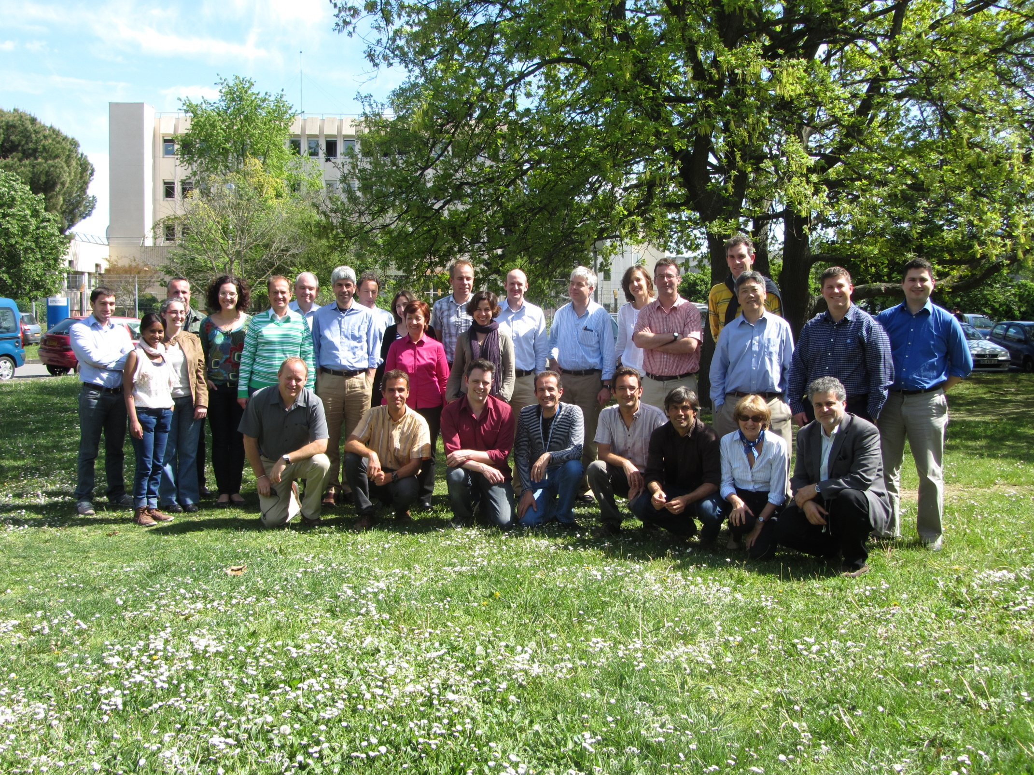
Figure 1: Expert and SLCCI project teams during the Selection meeting (Toulouse, May 2012)
- List of attendees:
Expert team: P. Woodworth, S Nerem, S. Vignudelli (CNR), J. Willis, R. Scharro, P. Y. Le Traon (IFREMER), S. Brown, R. Ponte, C. K. Shum, N. Picot (CNES)
CCI project team: A Cazenave (LEGOS), G. Larnicol, Y Faugère, M Ablain, S. Labroue, P. Thibaut, E. Obligis, I Pujol, N. Tran, B. Picard, A Ollivier, G. Dibarboure, MH Rio (CLS), G. Timms (LOGICA), D. Stammer (UoH), S. Rudenko (GFZ), O Andersen (DTU). M. Roca (IsardSAT), J. Fernandes, A Nunes (FCUP)
ESA team: J Benveniste, S. Dinardo
CMUG team: T. Phulpin (MF)
Invited: J. Dorandeu (Mercator-Ocean), B. Messygnac (LEGOS), P. Escudier; L Cerri (CNES)

Overview of all the new algorithms selected for all the missions
The algorithms selected during the Selection Meeting are displayed in the following table (green boxes) versus all the altimeter missions. The details of new algorithms selected are given in the next sections.
The unfilled boxes in the table mean that the same algorithms are used to perform the sea-level calculation as in AVISO products (see http://www.aviso.oceanobs.com/msl/). Most of the time, no new algorithm has been developed to replace the reference one.

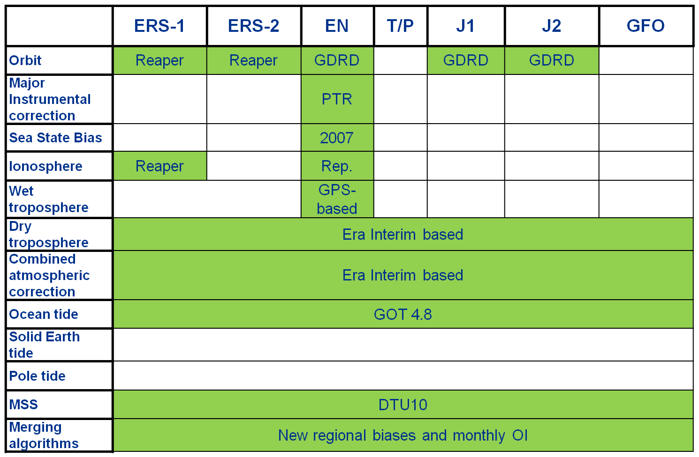
Table 1: New algorithms selected for the sea-level calculation within the SL-CCI project

Instrumental parameters

Algorithms selected
The peculiarity of the instrumental correction is that we know that some instrumental features have to be accounted for and that we know (by theory) how to take them into account. Most of the time, we have no doubt on how to apply corrections. The main interest of this work is thus to quantify their impact on the various space and time scales and in particular their impact on the Global Mean Sea Level rise.
Improvement of the PTR (Point Target Response) instrumental correction resolution (Power of the PTR and Time_Delay). This improvement has been already taken into account by isardSAT in the RA-2 L1b IPF. RA-2 reprocessed products (IPF V2.1, 2011 RA-2 reprocessing activity).

- The Improvement of the PTR has been selected.

Inversion of the sign of the PTR Time_Delay Correction in Ku band. The SLCCI project is the first project that has analysed the impacts of this correction even if this evolution was proposed more than 2 years ago. The current RA-2 reprocessing activity doesn’t include this evolution because it was not mature enough and agreed by ESA at the beginning of the reprocessing.Based on strong hypotheses on the instrumental processing applied on-board on the waveforms and on the PTR data (sometimes very difficult to confirm 10 years after the launch), this evolution induces an important modification of the slope of the MSL of about +2mm/year that makes the corrected RA-2 global MSL much more coherent with the Jason one and also much more coherent with the tide gauges.
- The PTR correction reversion has been selected.

Introduction of the IF filter effects in the PTR processing. PTR measurements account for the receiving chain of the altimeter. It is therefore necessary to correct the PTR measurements by the IF filter.

- The IF filter has been selected.

Improvement of the USO correction. This improvement has been already taken into account by isardSAT in the RA-2 IPF. Reprocessed products (IPF V2.1, 2011) account for this evolution. The USO correction that was computed in the RA-2 L1b was not correct. The CCI study has allowed to provide a L1b USO correction coherent with the USO correction computed previously in the RA-2 L2
- The improved USO correction has been selected.

Final selection:
When accounting for all these corrections, it has been showed that the RA-2 MSL is much more coherent with Jason MSL (difference of about 0.3 mm/yr) and with Tide gauges (difference of about 0.0475 mm/yr).
- All these corrections has been selected and implemented in the ground processing

Open issues and discussions
The open issues discussed during the selection meeting are the following:
- To analyze ERS-1 and ERS-2 reprocessed data (REAPER project) with the same methodology and tools
- To be sure that TOPEX and Poseidon data reprocessing will account for instrumental corrections
- For all missions, to improve all instrumental parameters impacting SWH and Sigma-0 stability
- Based on Envisat experience feedbacks (RA-2 was not designed for climate objectives), how to anticipate the improvement of instrumental parameter corrections to guarantee the ability to use new missions for climate applications (Cryosat, HY-2A...)
- 59 day oscillation remains a problem. Cause and impact on climate analysis not clear
- SWH is still a problem with “climate consequences”.
- I found the statement useful: “CCISl is helpful”. Many problems are research problems without answers on the table.
- ERS-1/2 work not proposed – at this point just ENVISAT.

Orbit solutions

Algorithms selected
For ERS-1 and ERS-2: on average the COMBINED Reaper orbits provide the best results for all the climatic applications with a significant improvement of the sea-level estimation in comparison with DEOS DGM-E04 orbit currently used in AVISO products. However, concerning some impacts on periodic signals or regional trends which are strong, we cannot determine which orbit solution is the best. For instance, the GFZ SLCCI orbit solutions containing new orbit standards (as ITRF2008) provide regional trends significantly different.
- Therefore the COMBINED Reaper orbit solutions have been selected since they display the best results in terms of consistency of ascending and descending passes as well as crossovers points as on long-term trends. However the GFZ SLCCI orbits solution clearly show interesting signals at basin scales which might be realistic.
For Envisat, Jason-1 and Jason-2: ESOC-V7 and preliminary CNES GDR-D orbit solutions significantly improves the estimation of regional sea-level trends with a strong reduction of longitudinal features (especially on Envisat). For the global MSL trend (only Envisat), we also detect a significant impact but it’s not possible to determine which orbit solution is the best. The impact on other climatic applications is null or low and it is also difficult to determine which orbit solution is the best.
- Although ESOC-V7 and preliminary CNES GDR-D orbit solutions provide similar improvements for scientific application, the preliminary CNES GDR-D orbit solution have been selected since it is available over a longer period until December 2012 included for Jason-1, Envisat but also Jason-2.

Open issues and discussions
The satellite orbit solutions selected were computed in different realizations of the International Terrestrial Reference Frame (ITRF): ERS-1 and ERS-2 combined REAPER orbit solutions were derived in the ITRF2005, while Envisat, Jason-1 and Jason-2 CNES GDR-D orbit solutions were calculated in the ITRF2008. It is important for climate applications to use satellite orbit solutions computed in the same ITRF realization using the same or very consistent models and standards instead of choosing the best orbit solution for each altimetry mission to avoid differences caused by using different reference frames and inconsistent models. That is why it is recommended to test new GFZ orbit solutions for Envisat, ERS-1, ERS-2 provided in April 2012, final CNES GDR-D orbit solutions for Envisat, Jason-1 and Jason-2 to be available in 2012 as well as TOPEX/Poseidon, Jason-1 and Jason-2 orbit solutions to be provided by GFZ and GSFC in 2012. All these new orbit solutions are computed in the same reference frame (ITRF2008) using the same or consistent models. A new selection procedure should be performed within the ESA CCN to choose the orbit solutions for the next release of the CCI products.
No GFO orbits have been tested in the framework of the CCI project.
A comment from Pierre-Yves Le Traon: significant differences at regional scales are observed, and we can not determine which orbit solution is the best. Therefore, these differences could be currently interpreted as errors.
An open issue is using time-varying gravity field models derived using GRACE data (2002-2010) that improve the orbit quality for Envisat, Jason-1 and Jason-2 at the given time span in the comparison with using static gravity field models for altimetry satellites, such as TOPEX/Poseidon, ERS-1 and ERS-2 at pre-GRACE time (1991-2002). The drift of J2 term was not linear in the past twenty years. So, the SLR-derived values of the J2 drift should improve orbit quality.
The reason(s) causing the differences in the mean sea level computed using ascending and descending parts of satellite orbits should be investigated.

Wet troposphere corrections

Algorithms selected
From models:
In terms of long term stability, the use of ERA Interim and NCEP reanalyses have a similar impact compared with the composite reference correction and the analyses of the regional impacts suggest that ERA Interim reanalyses are preferred to assess the radiometers stability. In terms of Sea Level performances and estimation of short temporal scale signals, ERA Interim reanalyses provides the best wet tropospheric correction compared with others modeled corrections and is thus preferred to estimate the quality of radiometers. This choice, particularly clear before year 2000 is still valid after this year in spite of the improvements implemented in the operational ECMWF since this year.

- The ERA-interim wet troposphere correction has been selected as a common reference to analyze the quality of the radiometer corrections for all the climate applications.

From radiometers: GPD algorithm
The GPD algorithm provides new estimations of the wet tropospheric correction, mainly in coastal areas. It has no impact on the global MSL trend estimation compared with the reference composite correction currently used in AVISO products. The MSL trend estimation is significantly modified in coastal areas with the GPD correction and it also improves the estimation of the sea level for mesoscale applications compared with the reference.
- The GPD algorithm has been selected for the estimation of the Envisat wet tropospheric correction for climate applications.

Open issues and discussions
The main issue concerning the wet troposphere correction is the long-term stability uncertainty which remains very large for GMSL studies: +/- 0.3 mm/yr.
The following open issues have been discussed during the Selection Meeting:
- Currently the GPD algorithm is only available for Envisat: it could be tested for all altimetry missions. There is particular interest for missions suffering missing corrupted radiometer measurements like GFO.
- The GPD algorithm improves the Envisat wet tropospheric correction where the radiometer wet tropospheric correction is known to be invalid: non ocean surfaces (ice, coastal areas), or rainy situations).
- The current GPD algorithm combines radiometer and GPS measurements with operational ECMWF model. An interesting conclusion of the CCI project is that ERA-Interim provides a better estimation of the wet tropospheric correction for sea level studies. Therefore it could be interested to apply the GPD methodology but combining radiometer and GPS measurements with ERA-Interim estimations.
- The ERA-interim wet troposphere correction has been selected as a common reference. This does not mean that it should be used for an absolute validation.
- It is well known that GPS data suffer sometimes for biases. A question was raised about the impact of these biases in the final product, and the possibility to correct the impact.
- There is a global recommendation to consider the climate requirements for the design phase of the radiometers, which seems not be always the case
- There is a need for a better communication between meteo, climate and altimetry communities. The action has been taken by CMUG (T. Phulpin) to look at the feasibility of such a meeting, and the possibily to organize it in 2012
- An issue regarding the need and the feasibility of a unique reference wet troposphere correction (combining models, radiometers, GPS …) dedicated to climate applications for all the missions is also discussed.

Ionosphere corrections

Algorithms selected
For ERS-1: the NIC09 correction improves the Sea Level for all scales. It has a big impact on the Global and regional Mean Sea Level, particularly for the year 1993, and a slight gain concerning mesoscale.
- The NIC09 correction have been selected

For ERS-2: the NIC09 or NIC09/GIM degrades the ascending/descending consistency for the global Mean Sea Level compared to the Bent/GIM correction, as well as the SLA variance.
- The NIC09 and NICO09/GIM corrections have not been selected. Therefore we keep the reference correction Bent/GIM.

Open issues and discussions
The discussion was focused on the ways for improving the model ionosphere correction use for mono frequency altimeters.
- No improvement of the quality of the GIM maps can be expected (last reprocessing in 2002)
- An empirical method adjusting the low frequency of GIM on dual frequency is a possibility but may look a bit too empirical
- The main proposition, suggested by Remko Scharroo from the expert team, is to use another altitude rescaling methodology within the GIM calculation. Today the altitude rescaling is performed using the IRI95 model. A statistical approach based on latest version of the model should be preferred, knowing that the ratio of the TEC below GPS altitude (20000km) and the TEC below the altimeter satellites (800 km or 1350) is a constant (Scharroo et al 2010). This method should be applied to ERS-2 and Envisat but also on Jason-1 as the part of the TEC left above 1350 km is negligible.
- Another way for improving the stability of the correction is to better handle the transition between 2 corrections impacts: NIC09/GIM for ERS-2 and DF/GIM for Envisat. The method used to correct the regional biases between missions (exemple J1/J2) on SLA should be applied to better handle these transitions.

Sea State Bias corrections

Algorithms selected
As expected, these analyses have confirmed that the 2007 2D version of the non parametric SSB correction is better than the currently used 2005 version particularly in terms of mesoscale applications (SLA performances).

Concerning the new 3D SSB correction, the impact is stronger for all the climate application with an impact close to 0.2 mm/yr on the global MSL for instance and higher than 1 mm/yr regionally. The spatial distribution of the SLA variance differences between the 3D SSB and the currently used 2005 2D SSB correction reveals a strong variance reduction (>5 cm2) located in regions of high ocean variability. Currently none diagnoses in RRDP are able to determine if this SLA variance reduction is an improvement in SSH computation or if it is an artifact for instance due to the changes in covariance terms between the SLA and SSB corrections.

For Envisat:
- Although the use of the 3D SSB correction in the MSL computation provides interesting changes concerning some climate applications, this algorithm has not been selected. We suggest to analyze the impact of this algorithm further before recommending its use for climate studies.
- Therefore, the 2007 version of the 2D SSB correction has been selected as a cautious position. Note that this recommendation stands only if the CCI SSH computation remains on the same standards as used for this validation. Otherwise as discussed in the open issues, due to its empirical form the SSB solution should be reprocessed based on the modified SSH values.

Open issues and discussions
Open issues concern different aspects:
- which SSB models for ERS missions (REAPER versions not yet available or new computation based on the CCI dataset) ?
- recommended correction of TOPEX SWH and sigma0 drifts affecting the SSB estimation and therefore the SSH computation over the 1996-1999 period;
- additional diagnoses needed to assess the quality of 3D SSB solutions for climate solutions (geophysical improvement vs variance reduction); it is still a research topic; use of the tide gauges for instance;
- SSB solution are determined to within a constant due to the constraint SSB (swh=0, u=0) = 0 due to lack of knowledge on absolute calibration of SSB values, but this constraint is to sensitive to changes in the light wind, low wave region. It is propose to use another constraint to fixed the model constant;

Combined atmospheric and dry troposphere corrections

Algorithms selected
The great interest of the ERA-Interim reanalysis for DAC, IB and Dry Troposphere corrections has been demonstrated. The improvement of sea-level using ERA-interim is maximum on first decade of altimetry due to the lower quality of operational ECMWF analysis during this period; this impact is also more important at high latitudes and in shallow waters where the atmospheric forcing is more energetic and the ocean has a strong dynamic response at high frequencies. On more recent missions, unexpectedly ERA-interim DAC shows similar performances as the DAC based on operational ECMWF analysis although the meteorological reanalysis has a larger spatial resolution than the analysis, except in some shallow water regions and some deep ocean areas where the finer resolution of operational forcing seems more appropriated. As far as DT correction is concerned, DT based on ERA-interim is improved compared to operational DT on all altimetry period, although improvement is weaker on last years. Note that the study also pointed out some strong impacts of ERA-interim on long-term scales but we could not determine if this impact is positive or not. NCEP reanalysis generally deteriorates results when compared to ERA-interim.
- Concerning DAC and DT, corrections derived from ERA-interim models have been selected on all altimetry period.

The 70-day filtered DAC has a strong positive impact on the estimation of mesoscale signals in shallow waters and at high latitudes (southern Ocean, north Pacific, Arctic ocean) for the missions concerned, ERS-2 and Envisat. Indeed this specific DAC has been performed to fulfill the Nyquist criteria of the 35-day sampling of these missions, and thus this correction allows removing more aliased high frequency signals in all these regions. This correction has also a non negligible impact on the estimation of regional MSL.
- The 70-day filtered DAC applicable for Envisat, ERS-2 and ERS-1 (35-day repetitive missions) has not been selected. Indeed, this new correction is not really useful when altimetry missions are combined together (as in SLCCI EECV products) since a large wavelength error correction calculated a posteriori is applied to correct the residual aliasing effect.

Open issues and discussions
The DAC correction is computed using a complex modeling, and several static and dynamic parameters. An open issue is thus the improvement of the DAC modeling and particularly of the following points:
- The bathymetry is one of the most important parameter of gravity waves modeling, in particular in the coastal areas. The bathymetry used in the operational DAC as well as in the ERA-interim DAC is mostly derived from Gebco 1minute grid. New global/regional bathymetry databases are now available and it would be interesting to analyze the impact of a new high resolution bathymetry on the DAC modeling. Particularly it would be worth testing the new parameters (bathymetry and mesh) developed within new FES2012 tide model project (CNES funded).
- At the present time, no Sea Ice Cover is taken into account into the DAC modeling, but simulations could be improved (at high latitudes and seasonally at least) while including this effect and using a varying sea-ice cover database: several sea-ice cover databases are available (monthly climatology or even operational parameter).
The improvement of the atmospheric forcing would also benefit to a better accuracy of the DAC correction:
- The wind-stress forcing could also be improved in the model thanks to the use of ECMWF wind-stress which includes heat fluxes ....
- The improvement of the atmospheric forcing resolution is also an open issue: a higher spatial resolution reanalysis would be worth testing, while a 3h ERA-interim database could help resolving high frequencies signals like S1 and S2 radiational tides.
The recommendation of the selection meeting is to use ERA-interim DAC on the entire period at the cost of a lack of accuracy in some coastal places on more recent years. However if one wants to use ERA-interim DAC for old missions only, the continuity between ERA-interim DAC and the operational one need to be investigated.

Ocean tide

Algorithms selected
For global ocean:

For the global ocean, the GOT4.8 model provides a small variance reduction on global ocean compared to GOT4.7, but a weak degradation is also detected in the Hudson Bay and in the Norwegian and the Barents seas. However, using GOT4.8 allows us to reduce 58.74-days signal estimated on MSL compared to GOT4.7 although this signal remains still stronger than if using FES 2004.

- For Global ocean, the GOT4.8 tidal model have been selected

At high latitudes:

At high latitudes, both TPXO7.0 and DTU10 tidal models provide a strong SSH variance reduction in the Arctic Ocean, and have also a significant impact on regional MSL (+/- 1 mm/yr). In northern Pacific and Atlantic, improvement of models tested is not clear if compared to GOT4.7.

- Therefore, concerning high latitudes the TPXO7.0 or the DTU10 tidal model could be selected for dedicated regional products in the Arctic area (rather than GOT4.7).

Open issues and discussions
Since RRDP work, several tidal models have been released or are still being developed and would be worth testing on global ocean and for high latitudes:
- Corrected DTU10 model is now available and would likely improve results in northern Atlantic and Pacific.
- FES2012 model is being developed (CNES funded project):
  - It is based on hydrodynamic finite element modelling (high resolution bathymetry, mesh)
  - It will benefit from the assimilation of nearly 20 years of altimetry (along-track data and crossovers)
  - New tidal atlas will be available in September 2012 (results will be presented at OSTST)
- New EOT11 model is now available
We need to check if one of these models has good performances in all regions particularly to have continuity between high latitudes and global ocean solutions.
If different models need to be used on different regions (Arctic, high latitudes, global ocean), and if continuity between regions needs to be preserved, the models used could be “mixed” at the boundary to get continuity.
Another open issue concerns Long Period tides.
- The impact of dynamic LP tides on MSL estimations is negligible.
- A few studies showed that the observed nodal tide is consistent with equilibrium expectation. Any nodal contribution to global averages of altimetry MSL, will be minimal for timescales of decades. At regional scales, and considering a few years, omission of nodal signal can induce errors of 2 mm/yr and perhaps double at the poles; but this problem disappears once records span a couple of decades.
Some ways forward for nodal tides understanding are to:
- Analyze long tidal gauges datasets available, to test for consistency with equilibrium globally and regionally
- Run a barotropic model for 19 years to check any dynamic effects at this frequency
- Check if uncertainty in mantle anelastic effects can also affect nodal tide calculation

One could also investigate further permanent tide variations while considering other test locations.

Mean Sea Surface

Algorithms selected
Both MSS (DTU10 and CNES/CLS 2011) are complementary since at very high latitudes the DTU10 MSS provides better SLA performances whereas elsewhere (in open ocean) the CNES/CLS11 MSS is better.

- Therefore, the DTU10 MSS has been selected in order to favour the Arctic Ocean which is an area of main interest for climate studies. On the other hand, the use of the DTU10 MSS instead of CNES/CLS 2011 MSS reduce the SLA performances in open ocean which could have an impact on mesoscale applications. However, as the Sea-Level CCI products (ECV) are monthly products dedicated to climate studies, this impact will be very low.

Open issues and discussions
The discussion concerning the MSS sea surface calculation have been mainly focusing on the data data editing procedure the more adapted at high latitudes.

Merging algorithms

Algorithms selected
Regional bias correction
The impact of empirical regional bias corrections proposed to better link
Jason-1/Jason-2 and TOPEX/Jason-1 MSL has been analyzed calculating the MSL trends from 1993 to 2010 and applying or not the regional bias corrections. The MSL trend differences range from -0.2 to +0.3 mm/yr from North to South. Considering ascending and descending passes separately, differences are higher from -0.5 to +1 mm/yr.
Notice that these new corrections have no impact on the global MSL trend as displayed. A very slight annual signal (lower than 0.2 mm of amplitude) is observed on global MSL differences. Indeed, the application of a grid correction (constant temporally but not spatially) generates an annual signal due to the annual data coverage variation in relationship with ice sea coverage (especially in northern hemisphere).
- The regional MSL bias corrections have been selected to link together the TP, Jason-1 and Jason-2 missions.

Mapping Method
The different mapping methodologies considered don’t lead to the equal reconstruction of signal required for climate applications.
- The impact on global MSL trend is actually very low. No specific methodology needs thus to be privileged for this application.
- The impact on regional MSL is higher. The datasets produced with a box average method or with a too smooth content does not allow to accurately retrieve the regional MSL. For this application, an OI method is recommended.
- The impact on regional Mean Sea Level is strong. The 1°x1° resolution is clearly not sufficient to resolve the mesoscale signals and to detect its inter-annual variations. 1/3°x1/3° resolution allows us to resolve a large part of these signals. The mapping method to use can not thus be a box averaged method (see appendix). An OI methodology, or equivalent, should thus be privileged. Using a monthly OI method (1/3°) dataset does not obviously allow us to reconstruct the mesoscale signals, but allows us at least to monitor the inter-annual variability of the mesoscale energy, and to accurately map the permanent fine scale structures.

- The Optimal Interpolation method to compute directly the SLCCI ECV at resolution of 1 month and 1/3° has been selected

Altimeter satellite constellation
The quality of the TP/J1/J2 series is optimal at mid and low latitude. The “Upd” (with all the satellites available) degrades the Sea Level around the geomagnetic equator due to errors in the ionosphere correction of ERS-1/2 series but allows to cover the high latitudes and is the best configuration for mesoscale application.

- The “Upd” configuration has been selected

Open issues and discussions
Different sources of errors were identified to impact the regional MSL precision:
Regional bias correction:
The geographical correlated bias between Jason-2/Jason-1/Topex-Poseidon are reduced using an empirical method. Notice that these empirical corrections strongly depend on the altimetry standards used on the Jason-1 or TOPEX MSL calculation. AS a consequence, if one of them is modified, especially concerning the orbit calculation, coefficients of the polynomial function should be revisited. The same approach on ESA missions (ERS-1, ERS-2 and Envisat) could be also applied in order to estimate and correct the MSL regional bias between these missions.
Orbit error:
Despite the improvements of orbit determination, the long wavelength error reduction is still necessary and crucial. The method currently used to reduce the long wavelength error is efficient for latitudes lower than 66°, and allows the introduction of additional altimeter measurements, without changing the long wavelength bias or trend. This is observed assuming that the measurements were previously adjusted on a reference mission. At the opposite, when not reference mission is available for the ajustement of the secondary missions, the sensitivity of using from 2 to up to 4 satellites is higher. This is the case above 66°. In this case, the multimission homegeneisazion process need to be improved.

Ionosphere correction:
This correction was pointed out on monofrequency altimeter measurements, and also – with a lower intensity – on dual-frequency measurements. It contains large scales errors that vary at interannual scales, according to the solar activity, and at seasonal scales. This kind of error signs on a gridded merged product, around the equator at the cm level.
A correction of this signal thus has to be studied. An option could be the improvement of the correction for monofrequency missions (Level 2 processing). An other option or complementary processing could be studied at the Level3 product generation, during the homogenization processing.

Mapping Method
The results obtained on regional MSL deduced from monthly product constructed using an OI method (DS4), underlined quite a strong signal in the equatorial Pacific Ocean. These differences need to be investigated, in consistency with the specificities of the ocean signal in the area (i.e. presence of strongly propagative signal). The parameterization of the OI, could be improved taking into account the link between temporal and spatial scales in a more precise way.

