

|  |
| --- |
| **Consortium Members** |
| Bandeau logos partners.png |



ESA Sea Level CCI

Detailed Processing Model (DPM) for Sea-Level CCI system

|  |  |
| --- | --- |
| Reference: | CLS-DOS-NT-13-248 |
| Nomenclature: | SLCCI-DPM-33 |
| Issue: | 1. 1 |
| Date: | Jun. 12, 14 |

| Chronology Issues: | | | |
| --- | --- | --- | --- |
| Issue: | Date: | Reason for change: | Author |
| 1.0 | 20/11/13 | Creation of DPM Issue 1.0 | M.Ablain |
| 1.1 | 12/06/14 | Answer to ESA review | JF Legeais |
|  |  |  |  |
|  |  |  |  |

|  |  |  |
| --- | --- | --- |
| People involved in this issue: | | |
| Written by (*): | M.Ablain, (CLS) | Date + Initials:( visa or ref) |
| Checked by (*): | G Timms (CGI) | Date + Initial:( visa ou ref) |
| Approved by (*): | G Larnicol (CLS) | Date + Initial:( visa ou ref) |
| Application authorized by (*): | ESA | Date + Initial:( visa ou ref) |

*\*In the opposite box: Last and First name of the person + company if different from CLS*

|  |  |
| --- | --- |
| Index Sheet: | |
| Context: | Baghera tool, project ACT-OCEAN |
| Keywords: | Oceanography, sea level |
| Hyperlink: |  |

| Distribution: | | |
| --- | --- | --- |
| Company | Means of distribution | Names |
| ESA | Email | Jerôme Benveniste, Bruno Manuel Lucas, Salvatore Dinardo |
| CLS | Email | Michael Ablain, Jean-François Legeais, Yannice Faugere, Gilles Larnicol |
| CGI | Email | Gary Timms |

|  |
| --- |
| List of tables and figures |

List of tables:

Table 1: List of corrections applied in the SL-CCI system to homogenize the SSH calculation 6

Table 2: List of reference documents for a detailed description of system and contact-point at CNES 13

List of figures:

Figure 1: Main components of the Sea-Level CCI system, based on the CNES SALTO/DUACS ground segment 3

Figure 2: Component outputs 11

Figure 3: Component inputs 12

|  |
| --- |
| Applicable documents |

AD 1 Sea level CCI project Management Plan  
CLS-DOS-NT-10-013

|  |
| --- |
|  |

|  |
| --- |
| Reference documents |

RD 1 Manuel du processus Documentation  
CLS-DOC

|  |
| --- |
| RD *2* PVSAR: Selection Meeting Report CLS-DOC-NT-12-125  RD 3 Algorithm Theoretical Basis Document (ATBDv1)  CLS-DOC-NT-11-009  RD 4 ALGORITHM DEFINITION, ACCURACY AND SPECIFICATION - BIBLI_ALTI : ALTIMETER LEVEL 2 PROCESSING: SALP-ST-BA-EA-15598-CN  RD 5 ALGORITHM DEFINITION, ACCURACY AND SPECIFICATION – SALTO-DUACS : ALTIMETER LEVEL 3 and 4 PROCESSING: CLS-DOC-NT-10-128 |

|  |  |  |  |  |  |  |  |  |  |  |  |  |  |  |  |  |  |  |  |  |  |  |  |  |  |  |  |
| --- | --- | --- | --- | --- | --- | --- | --- | --- | --- | --- | --- | --- | --- | --- | --- | --- | --- | --- | --- | --- | --- | --- | --- | --- | --- | --- | --- |
| |  | | --- | | Acronyms list |  |  |  | | --- | --- | |  |  | | DPM | Detailed Processing Model | | GDR | Geophysical Data Records | | IGDR  KIP | Interim Geophysical Data Records  Key Indicators of Performances | | LWE | Long Wavelength Error | | MSLA | Mean Sea level Anomaly | | NRT | Near Real Time | | OE | Orbit Error | | OGDR | Operational Geophysical Data Records | | OI | Optimal Interpolation | | SLA | Sea level Anomaly | | SSH | Sea Surface Height | |  |  | |

|  |
| --- |
| List of Contents |

1. Introduction 1

1.1. Purpose and scope 1

1.2. Property rights 1

2. Sea-Level CCI system description 2

3. Sea-Level CCI subsystem description 4

3.1. A Acquire Data 4

3.1.1. A.1 Passive data delivery or FTP retrieval 4

3.1.2. A.2 Detect, Date, ignore duplicate and corrupted data flow 4

3.1.3. A.3 Delete OGDR measures when acquiring the same IGDR measures 5

3.1.4. A.4 Synchronize the altimeter and auxiliary data 5

3.1.5. A.5 Cut in cycle/passes 5

3.1.6. A.6 Store the data acquired in a database 6

3.2. B Pre-process data 6

3.2.1. B.1 Apply consistent correction, ancillary data, models, references... 6

3.2.2. B.2 Merge short and large scale. 7

3.3. C - Perform input checks and Quality Control 7

3.3.1. C.1 Edit raw data 7

3.3.2. C.2 Apply Specific algorithms (iono filtering, radiometer extrapolation...) 7

3.3.3. C.3 Compute mono and multi-missions crossovers 7

3.3.4. C.4 Validate crossovers 7

3.4. D – Inter calibrate & Unify 8

3.4.1. D.1 – Compute mono-satellite orbit error (OE) reduction 8

3.4.2. D.2 – Compute multi-satellite OE reduction using a reference mission 8

3.4.3. D.3 – Compute multi-satellite OE reduction without reference mission 8

3.4.4. D.4 - Compute Long Wavelength Error (LWE) reduction with O.I. 8

3.5. E – Generate along track product 8

3.5.1. E.1 – Generate along track SLA product corrected by LWE and OE 8

3.5.2. E.2 – Validate the SLA product with the previous one 9

3.6. F – Generate merged product (Sea-Level ECV) 9

3.6.1. F.1 – Generate gridded SLA product (Map of SLA) 9

3.7. G – Perform output check and quality control 9

3.7.1. G.1 – Compute internal data quality control 9

3.7.2. G.2 – Compute product quality control 9

3.7.3. G.3 – Follow up data and products on long term 9

3.8. H – Do measures and build indicator 9

3.8.1. H.1 – Build Key Indicators of Performances (KIP) 9

3.8.2. H.2 – Build scientific metric 9

3.9. I – Store the built product datasets 10

3.9.1. I.1 – Delivery product on FTP server 10

3.9.2. I.2 – Update MIS Gateway with the last products 10

3.10. J – Archive / retrieve a “Product Dataset” 10

4. Internal interfaces 10

4.1. Inventory 10

4.2. Components outputs 11

4.3. Components inputs 12

5. Reference documents - a detailed description 13

# Introduction

## Purpose and scope

The Sea-Level Detailed Processing Model (DPM) report identifies and describes the main system and subsystems of the Sea-Level CCI prototype.

## Property rights

As the Sea-Level CCI prototype is based on the SALTO/DUACS infrastructure, supported by CNES, the system, subsystems and software used to generate Sea-Level ECV products are the property of CNES and CLS, and the detailed descriptions are not publicly accessible.

Therefore, in this document, we do not provide the whole DPM relative to SALTO/DUACS infrastructure, but only the description of the main subsystems of the SLCCI prototype with low level chart/block-diagrams, outlining at a high-level all the subsystems and how we can access the detailed information.

In summary, the DPM document is informative and provides a high-level description of the system and its main subsystems.

# Sea-Level CCI system description

This chapter intends to present an overview of the different processing steps activated to produce the Sea-Level CCI ECV products.

Figure 1 (below) provides an overview of Sea-Level CCI system based on the CNES SALTO/DUACS ground segment, where the processing sequences can be divided into 8 main steps:

Acquire Data

Pre-process data

Perform input checks and Quality Control

Generate Products

Performs output checks and Quality Control

Do measures and built indicators

Store the built product datasets

Archive / Retrieve a “Product Dataset”

The product generation is divided into three sub-steps:

Inter calibrate & Unify

Generate along track product

Generate merged product

Each step has its sequence of algorithms that can be activated to generate Sea-Level CCI ECV products.



Figure 1: Main components of the Sea-Level CCI system, based on the CNES SALTO/DUACS ground segment

# Sea-Level CCI subsystem description

This chapter describes each of the main components listed in Figure 1, their relationships and corresponding internal interfaces.

## A Acquire Data

This component has two main functions:

Acquisition

Synchronization of dataflows.

The acquisition function allows the downloading of altimetry data or ancillary data disseminated by the major space agencies such as CNES, ESA, NOAA, NASA, etc.

The synchronization function synchronizes altimetry data with all ancillary data needed to process the data.

### A.1 Passive data delivery or FTP retrieval

The acquisition function can be realized by two different methods:

Passive

Active

The passive method consists of scanning a given directory to determine if it contains new data to process. If so, the new data is moved to a working directory to be processed. In this case, the input data will be provided by a third party.

The active method follows the same process as the previous method, but on a remote server. If the acquisition finds a new file to be processed, this file will be downloaded into the working directory and then acquired. The interrogation of the remote server can be performed by different Internet Protocols: FTP, SSH, etc.

### A.2 Detect, Date, ignore duplicate and corrupted data flow

When the application detects a new file to process, the first step is to determine the time period covered by the data flow to be acquired. This step allows the application to characterize the period to process: already acquired, straddles with another period already acquired. It also allows for verifying the integrity of the processed data flow.

During this step, if the acquisition detects a problem the flow of data is moved to a particular directory and then an email is sent to the operators to warn them about the problem. In this special case, operators can study the problem that occurred during the acquisition of this data flow and depending on the result of the analysis data will be acquired or rejected.

### A.3 Delete OGDR measures when acquiring the same IGDR measures

This subtask is not called in the Sea-Level CCI system since only GDR data are used.

### A.4 Synchronize the altimeter and auxiliary data

The purpose of this algorithm is to synchronize altimetry data with all auxiliary data which will be needed to process this data. If the application detects that it lacks at least one auxiliary data then the data flow is moved into a waiting queue. When the acquisition receives the missing auxiliary data, the altimeter data (put on hold) will be automatically re-injected into the system and processed.

### A.5 Cut in cycle/passes

The system makes extensive use of the ‘cycle & pass’ numbers of each data flow. The information is sometimes missing, and it is reconstructed by the acquisition system whenever it is necessary.

### A.6 Store the data acquired in a database

This operation allows for the storing of the GDRs in the “altimetric” database. This database is an internal data base to be used for all other operations of the production of the system.

## B Pre-process data

### B.1 Apply consistent correction, ancillary data, models, references...

The homogenization process allows for the most recent corrections to be applied and for the models and recommended standards for altimetry products to process the different missions in homogeneous ways in the system.

In the Sea-Level-CCI system, the following list of SSH correction have been applied (see ATBD-V1 document: RD3).

|  |  |
| --- | --- |
| Algorithm Description | Altimeter standards |
| To compute additional corrections for the altimeter distance range at 1Hz | PTR correction with IF mask versus nominal PTR correction |
| PTR position drift correction versus nominal PTR correction |
| PTR power correction versus nominal PTR correction |
| PTR width correction versus nominal PTR correction |
| USO stability correction versus nominal USO correction |
| PTR correction with IF mask versus nominal PTR correction |
| To compute orbit altitude | COMBINED Reaper orbit solutions |
| Preliminary CNES GDR-D orbit solutions |
| To compute Wet troposphere correction from GNSS-derived Path Delay (GPD) | GNSS-derived Path Delay (GPD) algorithm |
| To compute the sea state biases | Sea State Bias No-parametric solution (Labroue 2007) |
| To compute ionosphere correction derived from Nic09 model | Ionosphere correction derived from Nic09 model |
| To compute the high frequency fluctuations | Dynamical atmospheric correction derived from ERA-interim model |
| Dry troposphere derived from ERA-interim pressure fields | Dry troposphere derived from ERA-interim pressure fields |
| To compute elastic ocean tide height and the load tide height | GOTv4.8 tide model |

Table 1: List of corrections applied in the SL-CCI system to homogenize the SSH calculation

### B.2 Merge short and large scale.

This subtask is not called in the Sea-Level CCI system since only GDR data are used.

## C - Perform input checks and Quality Control

### C.1 Edit raw data

The validation of raw data is a critical process to ensure that only the most accurate altimetric data is used. The validation rejects a small percentage of height measurements, but this data could be misleading because of the significant loss of product quality.

The quality control is based on the verification of the value of flags (rain, land / sea, etc.) quality thresholds of different parameters, and also on the complex algorithms based on the detection of false objects.

Valid and selected altimetry measurements will be tagged with a field containing a flag. This field will contain a zero value in the case of the measure being valid and a nonzero value in the case of the measure being invalid. In the case of an invalid measure, the value of the flag will indicate the reason why this measure has been eliminated.

Later in the process of generating products, only valid measures will be processed by the system.

### C.2 Apply Specific algorithms (iono filtering, radiometer extrapolation...)

The valid measures selected are processed for applying specific algorithm calculating corrections and bias necessary to calculate the SLA of the different missions processed by the system.

### C.3 Compute mono and multi-missions crossovers

Crossovers are the intersection of two satellite ground tracks. Each crossover is composed of two measurements, one from an ascending pass and one from a descending pass. There are two types of crossovers: mono-mission crossover (intersection of arcs from a single sensor) and multi-mission crossovers (intersection of arcs from multiple sensors). These datasets are used to estimate the performance of each mission, or for the calculation of the orbit error.

### C.4 Validate crossovers

Some crossovers are located in areas of high ocean variability (near the coast) or are affected by errors of calculation or interpolation. Therefore this processing is to select only crossovers which are trustworthy. Moreover, this step gives the performance of the different altimetry missions processed by the system before bias correction or long wavelength error minimization and orbit error minimization.

## D – Inter calibrate & Unify

### D.1 – Compute mono-satellite orbit error (OE) reduction

This algorithm estimates the orbit error deduced from the differences in Sea Surface Height (SSH) at mono-mission crossovers. This assessment is made on the reference mission of the system.

This process is based on the sinusoidal regression model on the observations derived from SSH differences on crossovers at 10 days.

The calculated orbit error is applied for the processed period to all data from the reference mission (altimetric database, crossovers mono and multi-mission).

### D.2 – Compute multi-satellite OE reduction using a reference mission

The algorithm is based on the assumption that there is an altimetry mission more accurate than other available missions. This mission is considered the reference mission of the system. The orbit error is deduced from differences at the crossovers of multi-missions.

Note that this process is based on the minimization by the method of least squares splines on observations derived from SSH differences at crossovers in 10 days.

The calculated multi-mission orbit error is applied for the processed period on all the secondary missions of the system (altimetric database, crossovers).

### D.3 – Compute multi-satellite OE reduction without reference mission

The method is a minimization of mono and multi-crossovers by least squares using cubic-splines interpolation. In the previous method detailed in Le Traon and Ogor, 1998, one satellite was supposed to be better than the other and we used the best satellite as a reference to improve the data of the second satellite.

The innovation in the new methodology is to consider both satellites equal and to correct one satellite with the other and vice-versa. The notion of a reference is absent. This technique is still under investigation and aims to improve the performances of all the satellites in the system simultaneously when compared to the existing method.

### D.4 - Compute Long Wavelength Error (LWE) reduction with O.I.

LWE is mostly due to high frequency ocean signals (residual tidal or barotropic errors). The optimal interpolation (OI) is used for LWE estimation. The aim is to estimate LWE values on along track positions and at a fixed time tag, given along track SLA observations being unequally distributed.

## E – Generate along track product

### E.1 – Generate along track SLA product corrected by LWE and OE

This step deals with SLA (anomaly compared to a mean profile) calculation and validation. The along track SSH measurements are interpolated on a mean track, and the temporal mean of the along track SSH (the so called mean profile) is removed in order to work with anomalies of sea level.A sophisticated process of filtering is then used in order to remove the outliers that are still present in the data and which can be detected thanks to the removal of the mean profile.

### E.2 – Validate the SLA product with the previous one

This along track SLA is validated by comparing the SLA measurement of the current production with the latest map of SLA (MSLA).

## F – Generate merged product (Sea-Level ECV)

### F.1 – Generate gridded SLA product (Map of SLA)

A mapping procedure using optimal interpolation with realistic correlation functions is applied to produce SLA maps at a given date. The procedure generates a combined map merging measurements from all available altimeter missions.

## G – Perform output check and quality control

### G.1 – Compute internal data quality control

The purpose of this module is to calculate statistics on the internal data to evaluate the altimetric measures performance. This process will calculate for example, the crossovers statistics to estimate the performance of the altimetric missions. These calculations may also be performed on the correction of EO and LWE.

### G.2 – Compute product quality control

This module will calculate statistics on the Sea-Level CCI products.

### G.3 – Follow up data and products on long term

The different statistical results obtained in previous stages will be inserted in a database. This information will be retrieved from the database to see change in these various statistical values over time.

## H – Do measures and build indicator

### H.1 – Build Key Indicators of Performances (KIP)

The purpose of this step is to calculate numerical values based on the acquisition status (date of availability for each altimetric mission, geographical distribution of the measures present / absent, etc.) and the quality of the Level2 altimetry products received.

### H.2 – Build scientific metric

The numerical values calculated in steps G1 and G2 will be expressed simply in order to create scientific metric.

In addition, indicators are delivered within the SL-CCI products and are made available to the users. They include:

1. The Global Mean Sea Level (GMSL) time series with the associated trend
2. Trends, amplitude and phase of the regional sea level

More details about how these indicators are built are described here:

<http://www.aviso.altimetry.fr/en/data/products/ocean-indicators-products/mean-sea-level/processing-corrections.html>

## I – Store the built product datasets

### I.1 – Delivery product on FTP server

The Sea-Level products are delivered on an authenticated FTP server.

### I.2 – Update MIS Gateway with the last products

Not yet available on SL-CCI system

## J – Archive / retrieve a “Product Dataset”

Not yet available on SL-CCI system

# Internal interfaces

## Inventory

The following internal interfaces have been identified:

Altimetric Database: This database contains all altimetry data exploited from Level 2 datasets. It contains the parameters needed to build the Sea Level content itself and all correction and environmental parameters needed for their processing and product generation.

Crossovers Database: This database contains all the crossover-related information (position, date, content of two measurements (one from each arc). It is primarily used by the orbit error reduction step and for the monitoring of the input data quality.

Statistics and follow-ups Database: This database is used for the long term information memory of mission performance and metrics.

Temporary production files: These files are generated during the production process. For practical reasons they remain online for a few weeks (to avoid effort duplication if datasets are needed to be reprocessed). They are not strictly necessary (no archive needed) as a production re-run would be able to generate this content again.

## Components outputs

The following diagram (Figure 2) illustrates the flow logic from component to internal interface (products):

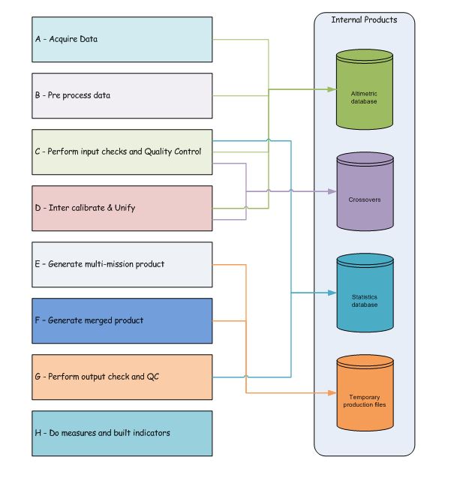

Figure 2: Component outputs

## Components inputs

The following diagram (Figure 3) illustrates the flow logic from internal interface (products) to relevant component:

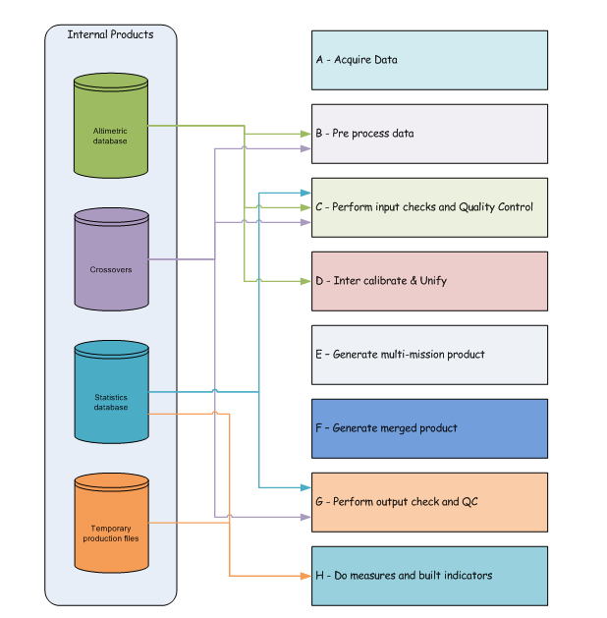

Figure 3: Component inputs

# Reference documents - a detailed description

As mentioned before in the report, the Sea-Level CCI system is based on the SALTO/DUACS system. The detailed description of the system is the property of CNES and CLS and therefore this documentation is not made publicly available. In Table 2 we provide the document reference details and the associated contact-point at CNES.

|  |  |  |  |
| --- | --- | --- | --- |
| Component Number | Description | Document | Contact |
|  | Acquire Data | RD 5 | CNES, Guinle Thierry [Thierry.Guinle@cnes.fr](mailto:Thierry.Guinle@cnes.fr) |
|  | Pre-process data | RD 4 for B-1 component  RD 5 for B-2 component |
|  | Perform input checks and Quality Control | RD 5 |
|  | Generate Products | RD 5 |
|  | Performs output checks and Quality Control | RD 5 |
|  | Do measures and built indicators | RD 5 |
|  | Store the built product datasets | RD 5 |

Table 2: List of reference documents for a detailed description of system and contact-point at CNES